The graph I am getting in my model :
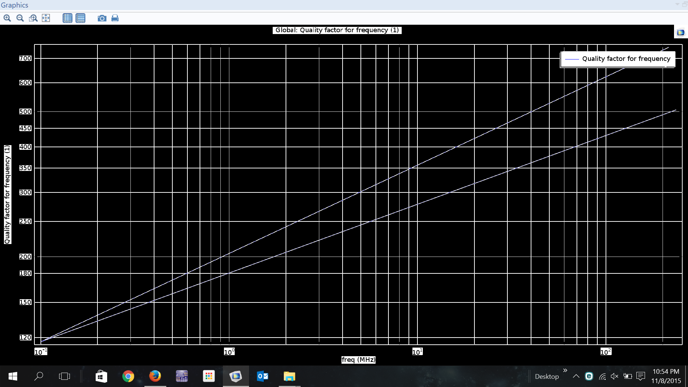

The graph that I need is:
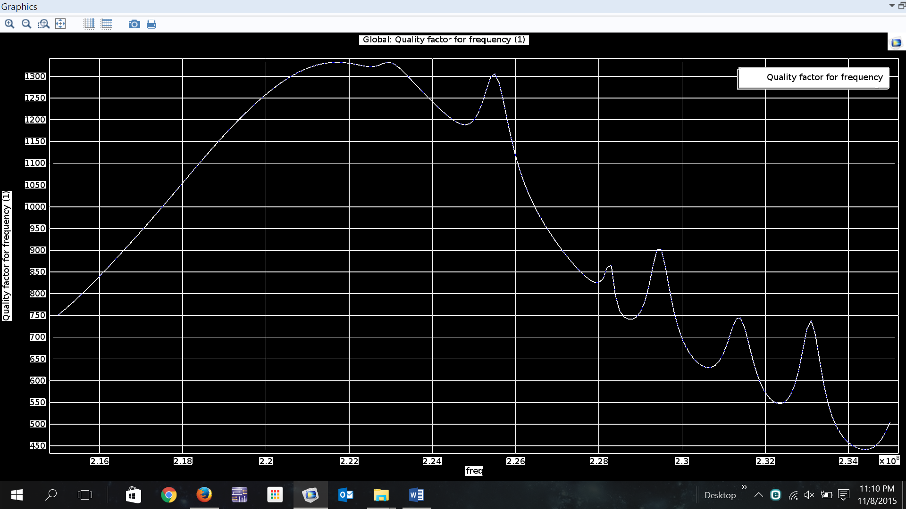
As you can see, I am getting a semilog graph but I want a normal graph with the frequencies mentioned on the x-axis. Kindly assist.

