The temperature in both bottom and top surfaces of the slab are kept constant and equal to 90°C and 30°C respectively. The sides of the slab are assumed to be insulated. The thickness of the slab is 4 cm. The initial temperature is 30°C. The density is 900 kg/m3. The thermal conductivity is 0.55 W/mK. The specific heat is 3800 J/kg K.

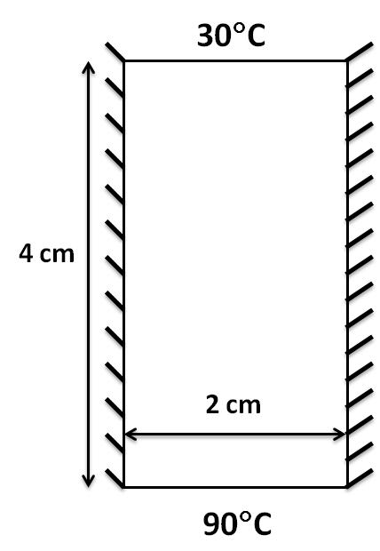

Starting from the following energy transport equation, and consider that temperatures are dependent on time; there is no fluid flow and no source terms. The only mode of heat transfer is by diffusion. So the problem is a transient diffusion problem with no convection and with a heat source of Q=40 J/ (m3. sec) :

 (1)

Determine the governing equation and use COMSOL to obtain 2D temperature profile.