COMSOL Simple Heat Transfer Test

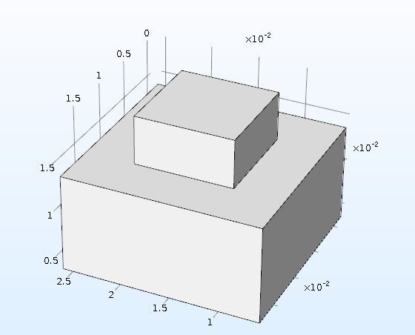

The top block is a 10x10x5 mm and made of Silicon Carbide

The bottom block is 20x20x10 mm and made of Copper

