I am using this method to solve my PDE:
I am using PDE modes
Classical PDEs
PDE, Coefficient Form
Then I am getting this window to draw my geometry

After this I am trying to feed my boundary conditions which is maximum at the corner and minimum at the centre of the edge
At point (-1,1) value is 40
At point (-1,0.75) value is 32.5
At point (-1,0.5) value is 25
At point (-1,0.25) value is 17.2
At point (-1,0) value is 10

At point (-1,-0.25) value is 17.2
At point (-1,-0.5) value is 25
At point (-1,0.75) value is 32.5
At point (-1,-1) value is 40
(-1,0)
(-1,-1)
(-1,1)

However in comsol I am getting this window 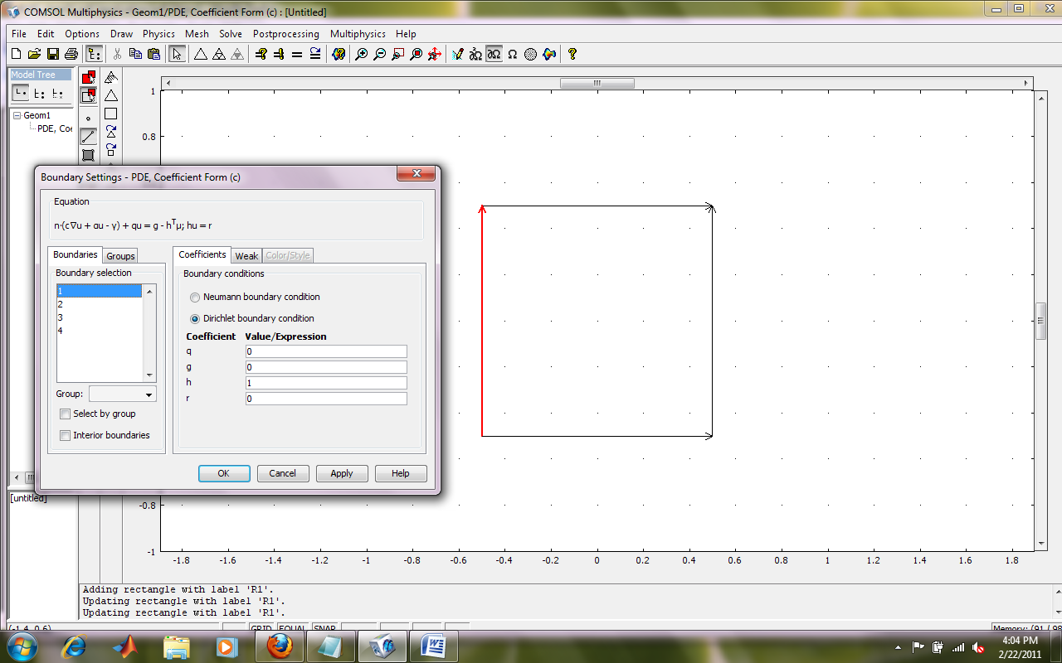
In which I can feed only one value for one edge which I do not want.
Please help me with this.

