Simulation Results:
Placing the microwaves generator at the interface of oil and water gives a slight rise in temperature because majority of the heat supplied was absorbed by water (central point of source is directly in front of interface).
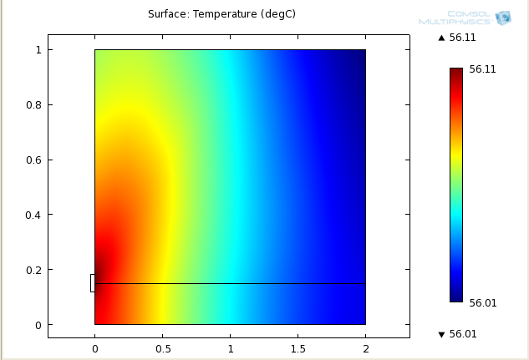
Moving the source a little bit up gives the following results (source moved a little bit upward)
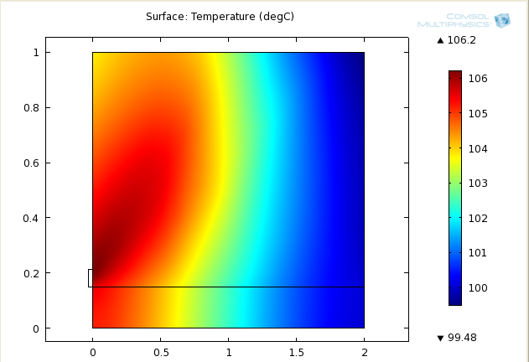
Moving the source down the interface, we get(source moved down from the interface):
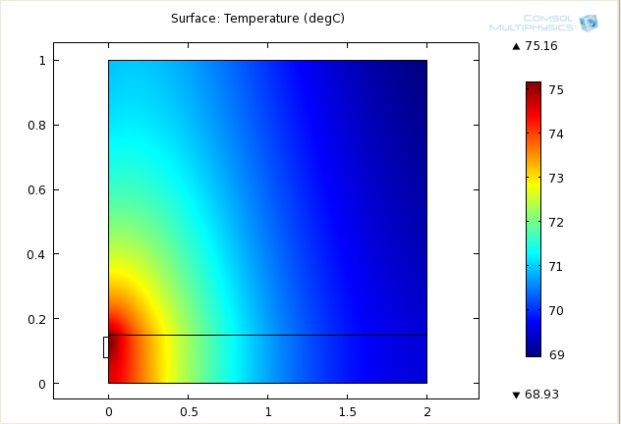
It is evident from the above results that the temperature distribution inside the oil depends heavily on the placement of microwaves source with reference to the oil water interface. The temperature rise is least if it is placed directly in line of sight with the interface.
Moving the source more down gives us (source moved down towards water-soil interface):
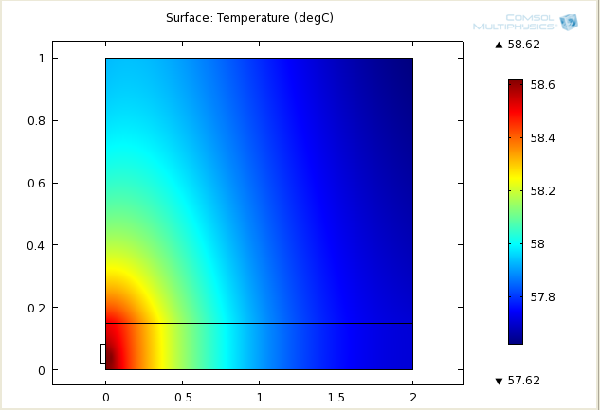
Placing the source at the top most end
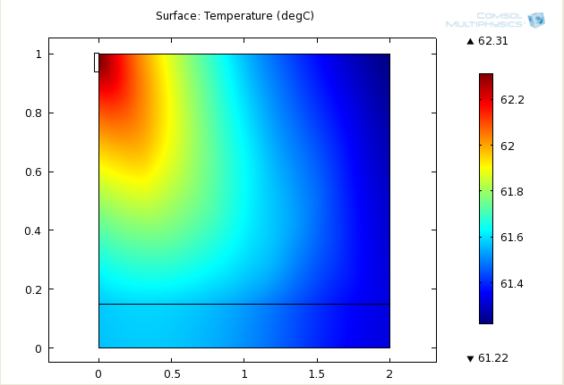
Placing the source at the upper most side of the oil domain, following Temperature distribution is observed showing that the heating effect of microwaves is affected by the presence of interfaces either oil water or oil soil or water soil etc (source placed at 0.9 m height).
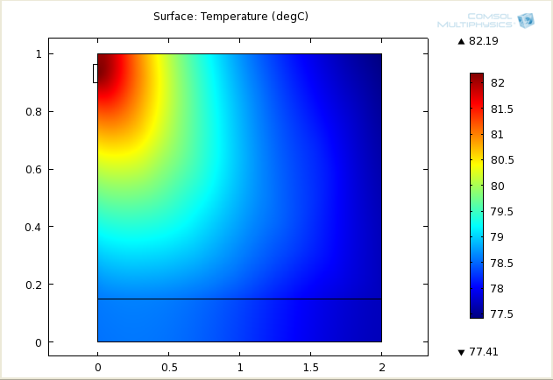
Moving the source down to 0.8 m:
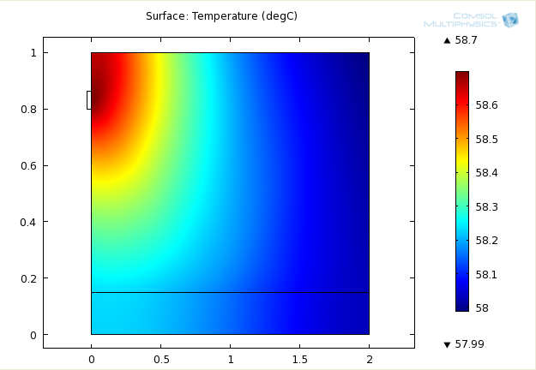
Placing the source at 0.7 m:
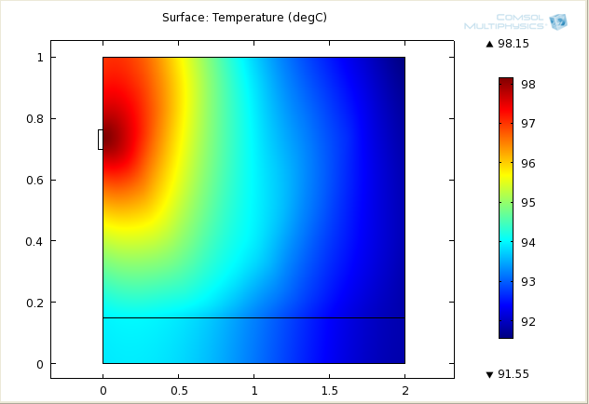

Place the source at 0.6 m
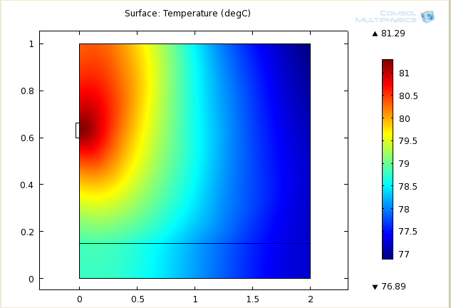
Placing the source at 0.5 m
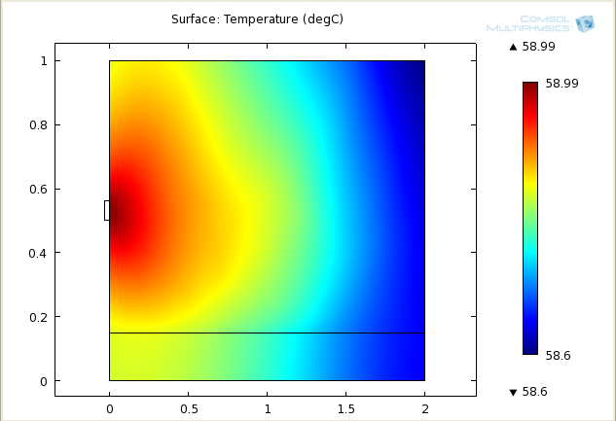

Placing the source at 0.4 m
